CSE 581

**Lab 15: Cursors**

**Nidhi Surya Prakash**

**SUID:215895619**

**Purpose:**

Create a function with a cursor.

**Steps:**

1. Create a function which will walk through the Enrollment table and calculate the average grades for each of the students[1]. Provide a **screenshot** of script execution. *The function will take in a student id as a parameter and then calculate that student’s average grade (round to hundredth).*
2. Execute the function. Provide a **screenshot** of execution, showing the results. Also provide a **screenshot** of the data, proving that your function worked as expected (please write a single SELECT statement that will provide the answers).

**SCRIPT:**

CREATE FUNCTION calcAvgGrade(@studentID as varchar(50)) RETURNS DECIMAL(10,2) AS

BEGIN

DECLARE @aG DECIMAL(10,2),@finalGrade int = 0, @c float=0.0, @grades int

DECLARE avgGradesCursor CURSOR FOR

SELECT FinalGrade FROM nsuryapr.CourseEnrollment WHERE StudentId = @studentID AND

FinalGrade is not NULL

OPEN avgGradesCursor

FETCH NEXT FROM avgGradesCursor INTO @grades

    WHILE @@FETCH_STATUS = 0

    BEGIN

     SELECT @c = @c + 1

SELECT @finalGrade = @finalGrade + @grades

     FETCH NEXT FROM avgGradesCursor INTO @grades

    END

SELECT @aG = ROUND(@finalGrade / @c,2)

CLOSE avgGradesCursor

DEALLOCATE avgGradesCursor

RETURN @aG

END

**CourseEnrollment table**

**Script:**

SELECT * FROM nsuryapr.CourseEnrollment

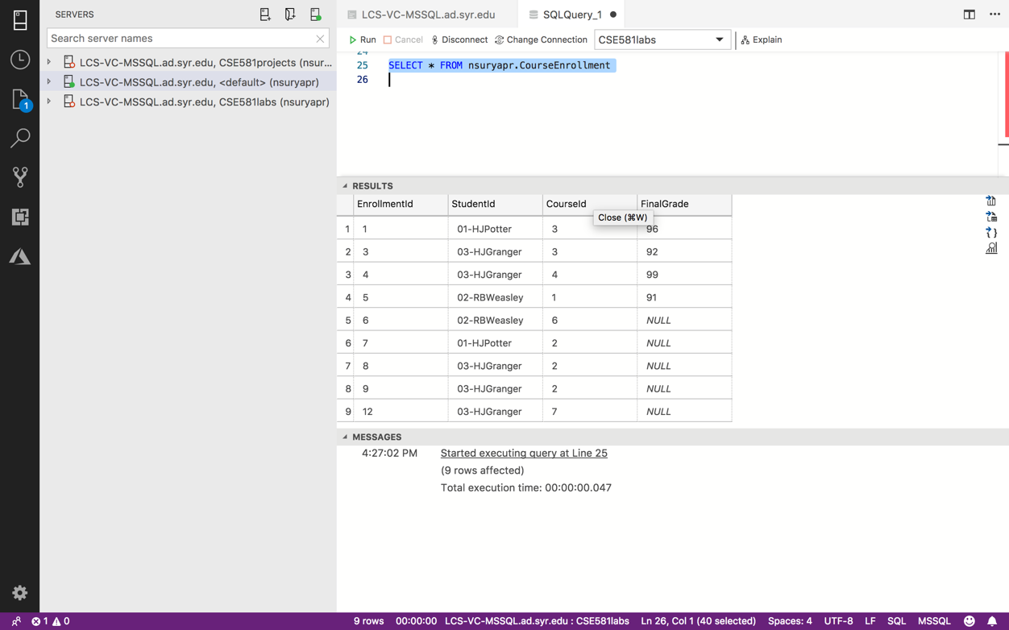

**Script execution**

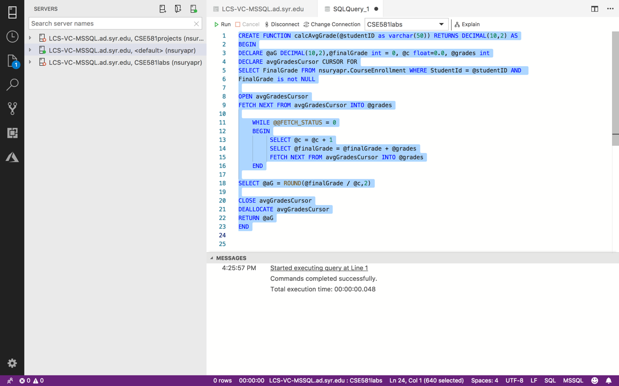

**Execution of function**

**Script:**

SELECT nsuryapr.calcAvgGrade('03-HJGranger') as Avg_Grade

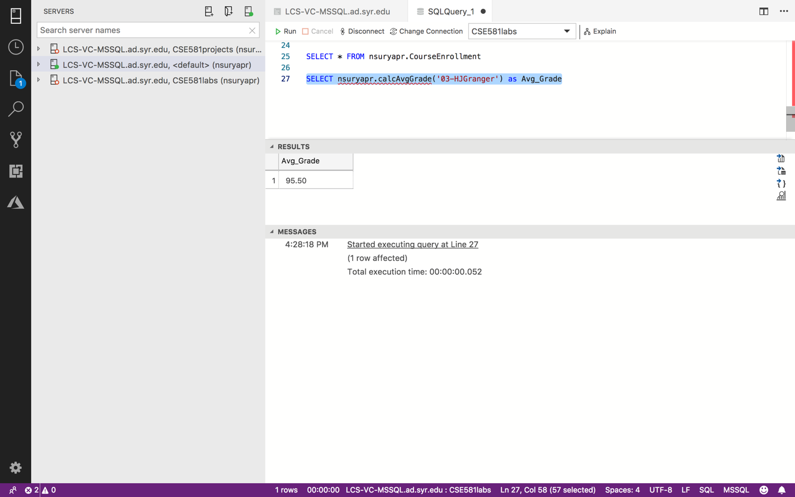

1. Please note that this can be done in easier ways, but the point here is to create a cursor and make sure it works.